MSU-Iligan Institute of Technology
CED – Integrated Developmental School
1st Quarter Exam
IT 10

Name: ________________________________________ Section: ______________ Score: _______

- Identify the following components. Write the correct answer on the line provided. (1 point each)
_______________1. 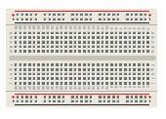
_______________ 2. 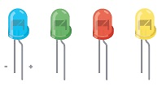
_______________ 3. 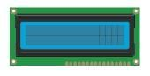
_______________ 4. 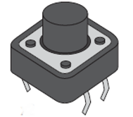
_______________ 5. 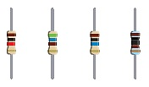

________________ 6. 
________________ 7. 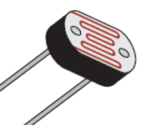
________________ 8. 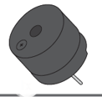
________________ 9. 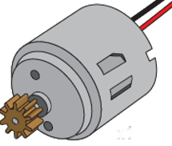
________________ 10. 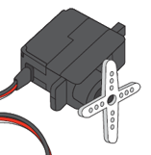

- Multiple Choice. Write the letter of the correct answer on the underline. (1 point each)

_____ 1. Which one is the fastest Led blinking?
- delay(500); b. delay(1000);
c. delay(1500);

_____ 2. Which one of the following is a user defined function?
- loop(); b. calculate(); c. setup();

_____ 3. Which function runs only one time?
- loop(); b. calculate(); c. setup();

_____ 4. To pause a system for 2 seconds in Arduino, we use ________ line code.
- delay(20); b. delay(200); c. delay(2000);

_____ 5. How many analog pin on Arduino board?
- 5 b. 6 c. 7

_____ 6. How many digital pin on Arduino board?
- 10 b. 12 c. 14

_____ 7. All of these are input devices EXCEPT
- Temp Sensor b. LED
c. Ultrasonic Sensor
_____ 8. What is the result of the following code print(7%3);
- 0 b. 1 c. 2
_____ 9. The following line of code, means pinMode(12, OUTPUT);
- Set the device in pin 12 as output.
- Set the device in pin 12 as input.
- Set the device in pin 12 set to Off state.

_____ 10. To control the current through a circuit we use
- Wire b. Sensor c. Resistor

_____ 11. Code writing and uploading into the Arduino board is done using _____?
- IDE b. PC c. SOME

_____ 12. The Arduino board is also called a _______?
- Timer b. Oscillator
c. Microcontroller

_____ 13. To ground the circuit _____ pin is used in Arduino.
- RESET b. GND c. PIN

_____ 14. Arduino IDE consists of 2 functions. What are they?
- Build() & loop() b. setup() & build()
c. setup() & loop()

_____ 15. digitalWrite(13, LOW); turns the LED on pin 13
- ON b. OFF c. DIM

- Decode the value of the following resistors and indicate the tolerance. Show your solution. (2 pts each)

_______________ 1. Brown, Black, Red, Gold.
_______________ 2. Yellow Violet, Yellow, Gold.
_______________ 3. Brown, Black, Green, Gold.
_______________ 4. Blue, Grey, Black, Gold
_______________ 5. Orange, White, Orange, Gold
_______________ 6. Grey, Red, Gold, Gold
_______________ 7. Yellow, Violet, Green, Silver
_______________ 8. Yellow, Violet, Black, Gold.
_______________ 9. Orange, Black, Red, Silver
_______________ 10.Green, Blue, Yellow, and Silver
- Problem Solving.
- Write a code that will turn an LED on and off using a push button. (5 points)

- Draw the Arduino circuit diagram where the LED will be turned on and off using a push button. (10 points)

Good Luck. Smile ☺

